**Macroeconomic Overview**

Over the past three years, the price of gold has oscillated from a high of $1366.25 per ounce in mid-2016 to a low of $1125.70 per ounce in late 2016. Gold prices peaked to similar levels in early 2018 and again in recent months.

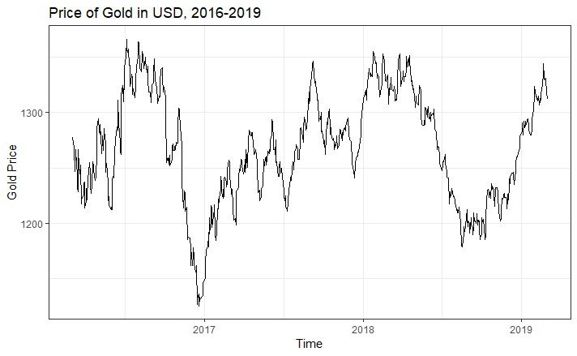

Gold prices can vary based on stock market activity, monetary policy, and simple supply and demand. Because gold is seen as a relatively stable store of value (at least compared to more volatile stock market investments), the poor performance of securities in the fourth quarter of 2018 saw a corresponding rise in the price of gold as demand increased when consumers turned to a more stable investment. Furthermore, Federal Reserve interest rate changes can also lead to changes in the price of gold, though these impacts are not always consistent. Finally, inflation can affect gold prices. If inflation is high (and therefore currency values are decreasing), then more investors may turn to gold, which may hold more stable value over time compared with national (or even foreign) currency. Take Venezuela for example. They have experienced inflation in percentages exceeding hundreds of thousands. Investors who stored their money in the stock market or in gold will largely have retained the value of their wealth. Those who kept their assets liquid in bolívares have seen their assets plummet in real terms.

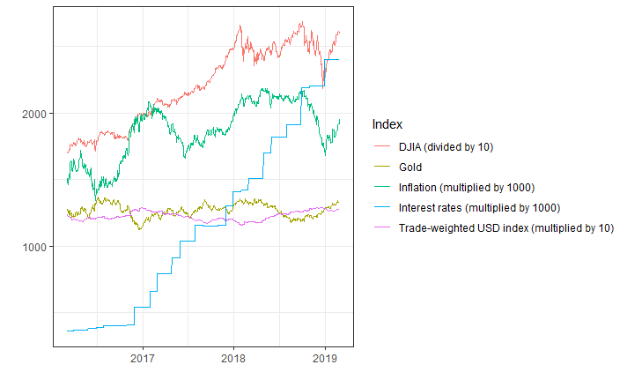

**Predicted Gold Price**

The average price of gold for the week of March 4-8 would be $1316.51. Individual daily price predictions are listed below.

|  |  |
| --- | --- |
| **Date** | **Price (USD)** |
| 3/4/2019 | $1318.25 |
| 3/5/2019 | $1317.36 |
| 3/6/2019 | $1316.49 |
| 3/7/2019 | $1315.64 |
| 3/8/2019 | $1314.80 |

A plot of these predictions as well as confidence levels is available on the following page.

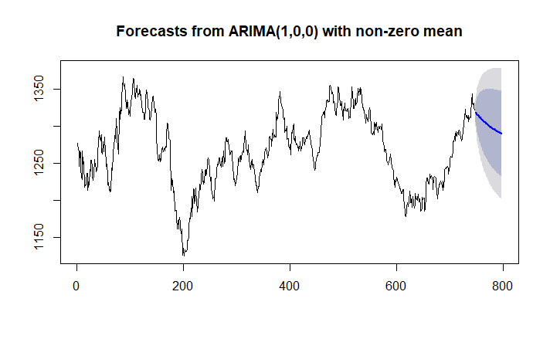

**Robustness Checks**

We computed the median absolute deviation of the residuals to determine how accurate our model was. We found that our model had a median absolute deviation of 6.76, suggesting it fit our data with high levels of accuracy.



Furthermore, you can see from the calculations below and the plot on the following page that the residuals of the ARIMA(1,0,0) model are normally distributed with a mean near 0.



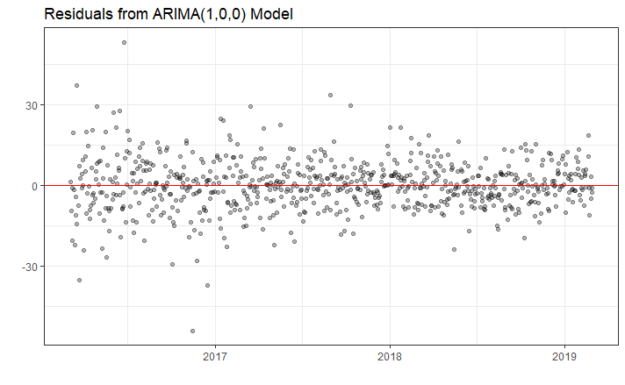

**Notes**

Please note that I used the most current three years of data, so my results will differ slightly from calculations made using the archive data from the [USA Gold website](http://www.usagold.com/reference/prices/goldhistory.php?ddYears=2018). I accessed these data directly from the St. Louis Federal Reserve using the `getSymbols` function from the `quantmod` package in R.